***Building a Sunrise/Sunset Finder in Python***

**The Brief:**

An API (Application Programming Interface) is a software program that provides communication channels following the HTTP protocol between 2 applications. It is usually used for allowing a client to request or update information from a server.

You are tasked to develop a Python program that will look for the sunrise and sunset times (UTC) for a specific location at a given date.

To do so, you will need to call 2 different API for:

* Converting a postcode to longitude and latitude coordinates and extract additional information ([https://www.zippopotam.us/](https://www.zippopotam.us/?ref=apilist.fun))
* Extracting the sunrise and sunset times for given longitude and latitude coordinates (<https://sunrise-sunset.org/api>)

**Description:**

In this individual assignment, you will develop a python program that will take 2 currency codes as input arguments. Here is the command for running your script:

python main.py <date> <post_code> <country_code>

Your script will return the following outputs:

|  |  |  |
| --- | --- | --- |
| **Scenario** | **Example** | **Output** |
| Success | python main.py 2022-10-04 90210 US | On 2022-10-04, the sunrise and sunset times for Beverly Hills (90210) in California, United States were respectively at 1:49:20 PM and 1:35:08 AM (UTC time) |
| Success | python main.py 2023-01-01 90210 us | On 2023-01-01, the sunrise and sunset times for Beverly Hills (90210) in California, United States will respectively be at 2:57:53 PM and 12:56:34 AM (UTC time) |
| Missing argument | python main.py | [ERROR] You need to provide 3 arguments in the following order: <date> <post_code> <country_code> |
| Missing argument | python main.py 2022-01-01 | [ERROR] You need to provide 3 arguments in the following order: <date> <post_code> <country_code> |
| Missing argument | python main.py 2022-10-04 90210 | [ERROR] You need to provide 3 arguments in the following order: <date> <post_code> <country_code> |
| Too many argument | python main.py 2022-10-04 90210 CA US | [ERROR] You need to provide 3 arguments in the following order: <date> <post_code> <country_code> |
| Incorrect country code | python main.py 2022-01-01 90210 USA | There is an error with Zippopotam API |
| Incorrect postcode | python main.py 2022-01-01 00000 us | There is an error with Zippopotam API |
| Incorrect country code and postcode | python main.py 2022-01-01 00000 usa | There is an error with Zippopotam API |
| Incorrect date | python main.py 2022/01/01 90210 US | Provided date is invalid |
| Incorrect date | python main.py 2022-01-41 90210 US | There is an error with Sunrise-Sunset API |

Your program will be composed of multiple files:

* **main.py**: main program used for running your business logics
* **checks.py**: python script that will contain the code for checking inputted arguments and date validity
* **api.py**: python script that will contain the code for making API calls
* **api_zippopotam.py**: python script that will contain the class used for calling relevant Zippopotam endpoints
* **api_sunrisesunset.py**: python script that will contain the class used for calling relevant Sunrise-Sunset endpoints
* **places.py**: python script that will contain the class used for extracting location information and times of sunrise and sunset
* **test_checks.py**: python script for testing code from checks.py
* **test_api_zippopotam.py**: python script for testing code from api_zippopotam.py
* **test_api_sunrisesunset.py**: python script for testing code from sunrisesunset.py
* **test_api.py**: python script for testing code from api.py
* **test_places.py**: python script for testing code from places.py
* **README.md**: a markdown file containing your details (full name, student id), a description of this project, listing of all Python functions and classes and instructions for running your code

Here is the flow chart of this program:

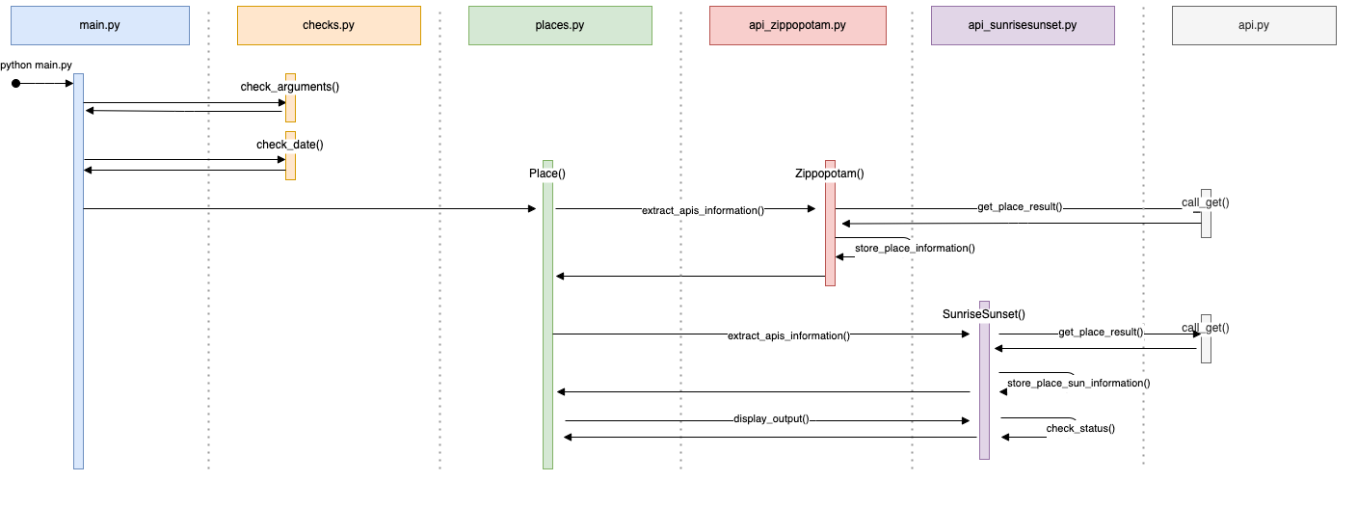

**Submission:**

You will submit a zip file containing your python scripts and documentation. The name of the zip file **SHOULD** follow this convention

You can find the structure template here:

The zip file needs to contain the following files (there shouldn’t be any folder):

* main.py
* checks.py
* api.py
* api_zippopotam.py
* api_sunrisesunset.py
* places.py
* test_checks.py
* test_api_zippopotam.py
* test_api_sunrisesunset.py
* test_api.py
* test_places.py
* README.md